**Declining Prime-Age Male Labor Force Participation Rate**

**Connor Krenzer\***

**ABSTRACT**

The US labor force participation rate among prime-age men has been declining for decades and shows no sign of returning to historical levels. A plethora of researchers have undertaken the task of explaining this phenomenon, focusing their causal factors upon the shifting of either supply or demand of labor. Most of the research on this topic notes the many changes undergone in the United States from the 1960s to today, so this paper lays out some of the most prominent arguments, and notes that men leave the labor force at a higher rate during recessions, particularly during more recent ones.

**INTRODUCTION**

The labor force participation rate measures the percentage of people in a country who are employed or unemployed. A person who is employed has a job while an unemployed person is someone who does not have a job but has actively looked for one at some point in the past 4 weeks. Anyone not included in either of these two categories is not considered part of the labor force. In the American economy, the demographic with the highest participation rate—both historically and presently—is prime-age men. Prime-age workers are those in the most productive period of their lives, ages 25-54. Concerningly, the prime-age male labor force participation rate has been declining for decades. Federal Reserve Chairman Jerome Powell cites this as one of the two major long-term issues facing the US economy (“The Latest: Jerome Powell” 2019). In 1960, the participation rate hovered around 97 percent. As of January 1st, 2020, that number rests at 89.3 percent—slightly higher than any month in 2016 but lower than any month in 2008. To provide the reader with some perspective, Figure 1 uses data from the Bureau of Labor Statistics (BLS) to graph this trend (BLS 2020).

**Figure 1**: Long-Term Decline in Labor Force Participation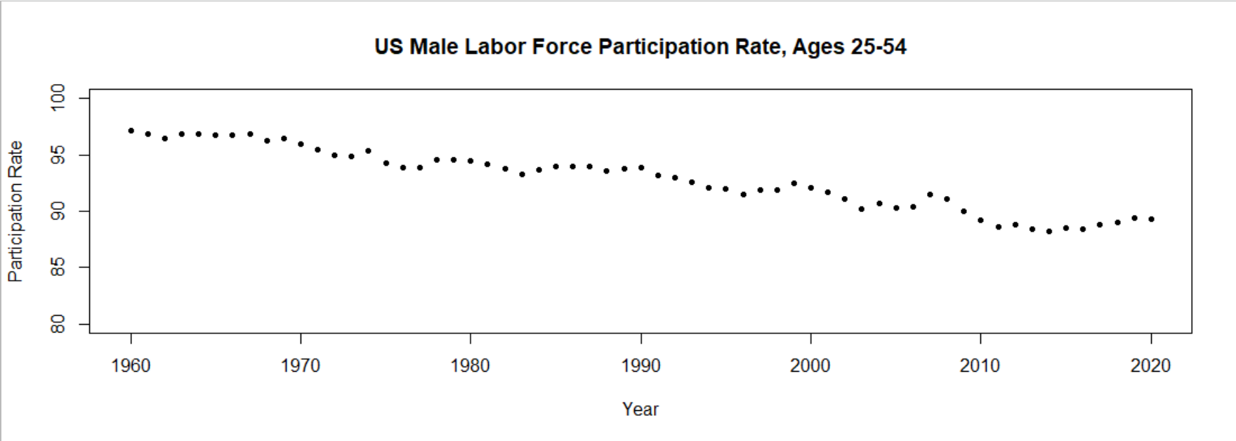

Source: CPS data.

When observing domestic economic trends, it is always good to put America’s situation in relation with other countries. Although typically having a lower overall unemployment rate, the United States has the third lowest prime-age male labor force participation rate among all countries in The Organization for Economic Co-operation and Development (Council of Economic Advisors 2016). For example, the United Kingdom—chosen as a developed economy hit especially hard by the Global Financial Crisis which could serve as a proxy for an economy similar to that of the United States—has a considerably higher proportion of its prime-age male population in the labor force. Figure 2 plots available data for an approximation of the UK’s prime-age male labor force participation rate next to that of the US with a line indicating 90% participation for ease of reading (BLS 2020; Leaker 2020a; Leaker 2020b; Leaker 2020c; Leaker 2020d). The age groups for men in the UK and US do not match up perfectly due to restrictions in data, but they are close enough to fairly compare the two countries. The difference between the UK and US prime-age male participation rates is stark considering each percent accounts for hundreds of thousands of potential workers. This is an important comparison to make because it emphasizes that although participation rates trended downward throughout the developed world, the decline’s extent establishes this as a uniquely American problem.

**Figure 2***:* UK & US Participation Rates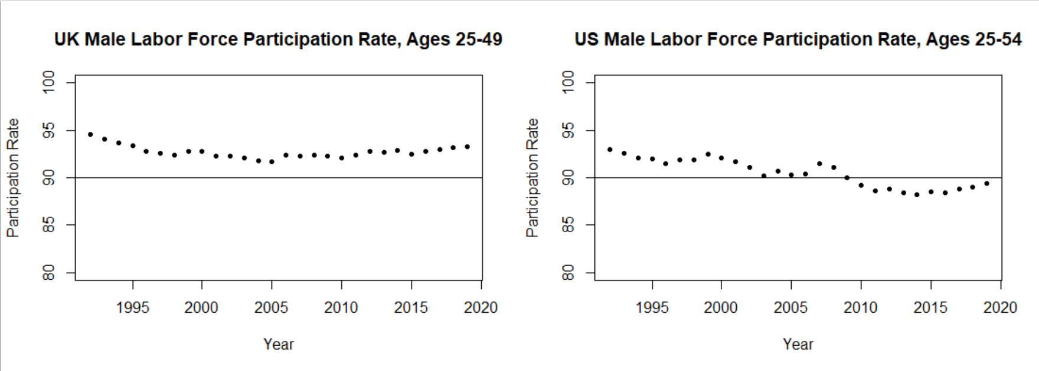

Source: CPS data.

The next section provides a description of inactive prime-age men. An overview of the data used in this paper is found after the characteristics section. A literature review falls after the methodology, detailing the arguments contained in research related to this topic. The conclusion will summarize the findings of this paper and consider the weaknesses of the current body of literature.

**CHARACTERISTICS OF INACTIVE PRIME-AGE MEN**

Inactive prime-age men often find themselves in lamentable circumstances. A report conducted by the US Congress Joint Economic Committee (JEC) has analyzed data from an under-utilized dataset—the “National Epidemiological Survey on Alcohol and Related Conditions-III,” or NESARC-III—and found many otherwise unavailable statistics about this group of people. In 2013, “roughly 45 percent of them [inactive prime-age men] indicate their current situation involves illness or disability” (JEC 2018). More promisingly, the report also mentions that somewhere around 15% of inactive men are in school, 5-10% are retired, and another 5-10% take care of domestic duties such as childcare. Twenty-five percent of this demographic do not fit into any of the aforementioned categories (JEC 2018).

Social ties appear weaker among inactive prime-age men. Compared to employed prime-age men, inactive prime-age men are less happy, have more adversity to overcome from childhood, and are more socially isolated (JEC 2018). One-third of prime-age inactive men report being incarcerated at some point in their lives (JEC 2018). Inactive men are twice as likely to say they do not get invited to engage with others and that it would be difficult to find someone to help them move. Also relevant to this discussion is where inactive men live. Prime-age men are not leaving the labor force uniformly across the US. Figure 3 shows a map taken from a 2016 article from the Brookings Institute indicating the concentrations of employed men in metropolitan areas across the United States (Berube 2016). Although this only shows employment rates, one would suspect that participation rates to follow a similar trajectory. Most of these men live in the South, specifically the Southeast, in rural areas (JEC 2018). Areas in the South have far lower employment rates than areas with more robust agricultural or service-based economies such as those found in New England or the west coast. This is consistent with demand-side arguments (which will be discussed in the literature review) that participation rates have fallen most for those with lower levels of education.

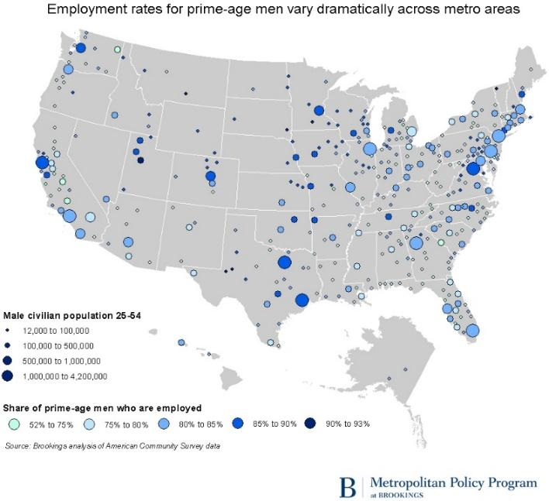**Figure 3**: Concentration of Employed Prime-Age Men

For the economy, the most disheartening statistic of all for this group is that they are disinterested in working. The JEC (2018) report notes that, “only 12 percent of able-bodied prime-age inactive men indicate in household surveys that they want a job or are open to taking one.” People in this country with much to offer go through some of their most productive years of life without going to work. What makes matters worse from the standpoint of a macroeconomic policymaker is that they do not even want to.

**METHODOLOGY**

The main tool used to analyze datasets in this paper is the programming language R.1 Graphs in this paper were created in R using numbers pulled directly from the data’s originator. The rest of this section details the construction of Figures 1-3.

To create Figure 1, numbers taken from Federal Reserve Economic Data (FRED) were plotted (BLS 2020). Only the values for January of the year the point represents is depicted by the graph.

The US data in Figure 2 was plotted using the same method as in Figure 1, except the values begin with data from January 1992. The UK data in Figure 2 was calculated with data of the annual average for the economic inactivity rate of men in the age groups 25-34 and 35-49, beginning in 1992. The UK Office for National Statistics defines Economic Inactivity as: “People not in employment who have not been seeking work within the last 4 weeks and/or are unable to start work within the next 2 weeks” (Leaker 2020a). Finding the data compatible for comparison, it was then translated from an inactivity rate to a participation rate by subtracting the annual values from 100. To combine the 25-34 and 35-49 age groups, the total inactive male population in the age group of 25-49 was divided into the population of inactive men ages 25-34. The total inactive male population for men ages 25-49 was also divided into the population for inactive men ages 35-49. Doing so calculates the weight of both age groups. Then, the weighted inactivity rate for men ages 25-34 was added to the weighted inactivity rate for men ages 35-49. A key limitation of this graph is not only the lack of data for British men ages 50-54 but also that each point on the US graph represents the labor force participation rate for one month out of the year while the UK data is an average for the entire year. Year-to-year fluctuations in labor force participation rates are quite low, so the actual value of this disparity should be close to the displayed data and therefore not impact the present author’s analysis.

Figure 3, the map of the United States showing the prime-age male employment rate by metropolitan area, was taken directly from a paper by the Brookings Institute (Berube 2016).

The data in Figure 4 was pulled from the Bureau of Labor Statistics’ CPS database. The data contains numbers for men ages 25-54 of all men, black men (starting in January 1972), Hispanic men (starting in November 1994), and white men (starting in January 1954). Data for Asian men was available starting in 2010, but was excluded because the data only cluttered the charts and made them harder to interpret. The simple average was taken for each period indicated on the x-axis and plotted. Note that the data for expansions include the first and last month of recessions, which are typically not included in graphs portraying economic expansions. They were added because it seemed more appropriate to include these months because the business cycle does not reach a trough on the last day of the month—the recovery ‘actually’ begins sometime in the middle of the month, not at the start of the next one. Regardless, the inclusion of these two months likely makes a negligible difference in the bar heights of the graphs. Data for 2020 only goes through August, but it was included to provide the reader with some perspective as to how different this recession is to the ones in the past.

The charts in Figure 5 were also calculated using the same data from Figure 4, only an index with a base of 100 was used at the beginning of each period to better show the changes in the labor force participation rate over time. The base month of each index is indicated on the y-axis of each chart.

**LITERATURE REVIEW**

A respectable collection of literature on declining male labor force participation rates has accumulated over the years, with each new study containing partial answers proving conflicting arguments. Research on this subject has centered around causes that can be boiled down to supply- and demand-side arguments. Reference to supply- and demand-side arguments do not, in this paper, refer to the political persuasion of the researcher but rather to the variables that shift the participation rate of prime-age men. All explanations have noteworthy shortcomings—meaning a decisive answer to this phenomenon does not exist—which will be discussed in the conclusion.

Demand

Reference to demand-side explanations of the decline in prime-age male labor force participation usually boil down to the notion that fewer job opportunities exist for men, some of whom found themselves unable to find work and dropped out of the labor force in response. For example, if employers are not looking for the skills that job applicants have, certain applicants may eventually quit looking for a job out of frustration from rejections. Employers do not demand workers who lack certain skills and the worker drops out of the labor force altogether—thereby lowering the labor force participation rate.

Arguments proposing a demand-side shift tend to focus on structural changes in the composition of the jobs landscape in the United States. Federal Reserve Bank of Kansas City economist Didem Tüzemen (2018) contends that reduced demand for middle-skill jobs from job polarization due to technological change and globalization is a key contributor to the decline in participation. She finds, “that from 1996 to 2016, the nonparticipation rate increased most for men with only a high school degree, some college, or an associate’s degree and for men on the younger end of the prime-age range (25-34)” (Tüzemen 2018, pp. 5-6). She rejects supply-side arguments claiming more men are living off alternative income sources such as welfare or partner income. She specifically states that, “While the share of prime-age men receiving SSDI [Social Security Disability Insurance] increased from 1 to 3 percent from 1967 to 2014, the labor force participation rate among prime-age men declined by 7.5 percentage points over the same period” (Tüzemen 2018, pp. 16). Since SSDI recipients have increased little with respect to prime-age men, Tüzemen reasons, benefits can explain relatively little of the increase in inactivity.

A paper from economists at the National Bureau of Economic Research contains similar findings to Tüzemen, explaining that the share of employment in middle-wage jobs has declined, while employment in both high – and low-skill jobs has increased since the mid-1990s (Cortes and others 2014). They claim, “This ‘hollowing out’ of the middle of the wage distribution has been linked to the declining share of employment in occupations with a high content of *routine tasks*—those activities that can be performed by following a well-defined set of procedures” (Cortes and others 2014, pp. 1). Routine occupations disproportionately employ middle-skill workers (high school graduates and those with some college education), particularly men. As middle-skill men are pushed out of their jobs, they are forced to find new ones either find new ones or remain unemployed. Some men who did not find work gave up their search entirely, so they no longer appear in unemployment statistics (Cortes and others 2014).

Supply

Supply-side explanations of the decline in prime-age male labor force participation have greater variation in explanations than do those of the demand-side. The essence of supply-side explanations of shifts in the participation rate, however, is described concisely by Black et al. (2016) when they explain that supply-side arguments are “characterized by prime-age men choosing to reduce their labor supply for a given set of labour market conditions.” An example of a supply-side hypothesis for declining participation rates is that more men retire early than in the past. Retirees do not want to work. Accordingly, they do not look for jobs—they are out of the labor force.

Arguments that propose a supply-side shift of workers can be divided further into one of two groups: those who believe men are no longer interested in working and those who believe men are unable to work because they are unhealthy, either mentally or physically. Princeton University economist Alan Krueger believes the decline in labor force participation has occurred because men deal with daily pain which creates a barrier to entry to the labor force. Using a survey of prime-age men he conducted online, Krueger finds men holding very poor measures of subjective wellbeing and little meaning in their lives. In addition, he claims that just shy of half inactive prime-age men take pain medication daily—with nearly two-thirds of them taking prescribed medication (Krueger 2016). A key criticism of Krueger’s approach is that the causality of the pain is hard to identify. Are men in poor health because they are out of the labor force, or are they out of the labor force because they have poor health (Tüzemen 2018)? Another important criticism of this study is that the survey only has data for one point in time, so it is not possible to compare men’s subjective pain levels to those in the past (Winship 2017). Men very well could have worked under high levels of pain in the past, but—for one reason or another—are able to get by without working today. Regardless, Krueger recommends increasing social healthcare spending and pain management interventions to improve men’s health, which should assist them with reentry to the labor force (Krueger 2016). A follow-up study the next year also found inactivity to rise more in areas with higher rates of opioid prescriptions (Krueger 2017).

John Coglianese, an economist at the Federal Reserve Board of Governors, offers evidence that the labor force is not as dismal as Krueger and the demand-side arguments seem to suggest. He writes about the rise of what he calls “in-and-outs” in the labor force. In-and-outs are people who take, “infrequent breaks out of the labor force in between jobs, but . . . are otherwise continuously attached to the labor force” (Coglianese 2018, pp. 2). These men make up somewhere between 20-40% of the composition of inactive prime-age men (Coglianese 2018). They presumably fund these breaks using savings and alternate income sources. Additionally, Coglianese provides evidence to suggest that the rise of in-and-outs is not a result of labor market demand for prime-age men. He notes that although offshoring and automation have driven some men from their jobs, average real incomes have still risen since 1977—meaning men do not have less of an incentive to work than in the past with respect to pay, at least in an absolute sense (Coglianese 2018). Further, in-and-outs have sprouted up in all industries and occupations, making the hypothesis that men are taking breaks in particular occupations unlikely (Coglianese 2018). In-and-outs differ significantly in spending habits from other types of unemployed people. Unlike the traditionally unemployed, in-and-outs do not sharply reduce spending; they have similar spending habits to retired people (Coglianese 2018). Moreover, in-and-outs do not suffer losses in income that are typically associated with long-term unemployment, possibly because they are more educated than inactive prime-age men overall (Coglianese 2018).

Scott Winship, in a working paper for George Mason University’s Mercatus Center, argues the rise in prime-age inactivity is a direct result of easier access to welfare benefits—particularly Social Security Disability Insurance—that make men disinterested in working. He provides harsh criticism to a report that researchers such as Tüzemen and Kreuger cite heavily in their papers, and, in the process, counters many demand-side arguments and a few supply-side arguments too. Winship disputes a claim from a 2016 Council of Economic Advisors report stating that men have not left the labor force because of availability of other earners in the household. The CEA report reasons that because there has been a declining likelihood of inactive prime-age men living with another earner, the availability of other earners is an unlikely cause for rising inactivity (CEA 2016). He counters that, “even if the number of inactive prime-age men without other earners grew at an even faster rate, the continued availability of other earners may be an important cause of rising inactivity” (Winship 2017, pp. 10). Even though the proportion of inactive prime-age men without another earner has increased, a large portion of this demographic still has other earners in their households. Winship concludes this point writing, “The continued availability of other earners may be an important cause of rising inactivity” (Winship 2017, pp. 10).

Winship believes the CEA report understates the extent people can avoid working by accepting social expenditures. The CEA report finds that from 1967 to 2014 there was a 7.5-point increase in inactivity but only a 2-point increase in the share of prime-age men receiving SSDI benefits (CEA 2016). The CEA made an inappropriate comparison, Winship argues, because the 7.5-point increase should be compared to the growth of the share of prime-age men who are inactive and receiving SSDI—of which there was a 3.3-point increase (Winship 2017). To clarify, the difference is that the CEA’s comparison was between the 7.5-point increase in prime-age male inactivity rate and the share of *all* prime-age men—both active and inactive—receiving SSDI benefits, while Winship’s comparison was between the 7.5-point increase and the share of *inactive* prime-age men receiving SSDI. Using his computation, approximately 40% of the rise in prime-age male inactivity is explained by receipt of federal and state disability benefits (Winship 2017). The CEA report goes on to claim that men have little incentive to get on disability because the poverty rate is high and increasing for inactive prime-age men (CEA 2016). One interpretation is that this claim is meant to counter supply-side arguments by insinuating that supply-side explanations implicitly assume inactive prime-age men are not pragmatic people who—by not participating in the labor force—effectively choose to live in poverty. The official poverty rate was 28% in 1968 and rose to 36% by 2014 (Winship 2017). Winship notes that the poverty rate is flawed for a variety of reasons—among them is the fact that nonwage benefits are not included its calculation. Winship creates his own measure of poverty and finds that, “using a measure of income that includes nonhealthy, noncash benefits, takes taxes into account, and pools the incomes of cohabitating partners, and using the best measure of inflation to update the poverty line over time, the poverty rate for inactive men was 24% in 2013, down from 32% in 1969” (Winship 2017, pp. 13-14). More inactive men escape poverty today than in the 1960s.

Replying directly to Krueger, Winship finds that improvements in technology have made prime-age men far healthier today than in the past. The problem, Winship argues, with Krueger’s hypothesis that declining levels of men’s health account for the decline in prime-age labor force participation is that Krueger’s survey is not consistent with national figures on *objective* health measures—at least since the 1990s for which there is data (Winship 2017). It is also important to note that objective measurements of health have declined for middle-age non-Hispanic white men, but they have mostly been offset by improvements in the conditions of Hispanic white men and nonwhites—so aggregate statistics for inactive prime-age men should not be affected by these changes (Winship 2017). Finally, Winship finds that the average person on SSDI makes about what a full-time minimum wage worker makes after taxes—even when ignoring Medicare benefits—which makes the opportunity cost of working too high for many people. Claimants’ attorneys also have an incentive to keep people on welfare because—if successful—they can be paid from the retroactive benefits they win for their clients (Winship 2017).

**Graphical Analysis**

This builds upon the demand-side literature by finding that the rate at which men leave the labor force is augmented during recessions. Labor force participation data suggests that more recent recessions have had a greater effect on the rate at which prime-age men leave the labor force; men leave the labor force at a faster pace during recessions than during expansions. The CPS data from which this conclusion was reached disputes the notion that financial hardship brought on by economic downturns cause men to re-enter the labor force and earn any income available to them. For readers searching for reasons why more recent recessions might have a greater effect on prime-age men, I refer the reader to research on the changing composition of the US economy, such as work from Olney and Pacitti2 or the demand-oriented claims outlined in the previous section. Do note, however, that explanations for prime-age men being affected more by recessions or being less responsive to recoveries are beyond the scope of this paper.

Figure 4 below shows the average percent change from a year ago of prime-age male labor force participation rates per month of all National Bureau of Economic Research-defined recessions and expansions. What is interesting to point out in this figure is the striking similarity in changes of the labor force participation rate between all races and white men. Granted, white men make up the majority of respondents in this statistic--especially the further back in time one goes--but the decline in white men's participation rate is smaller than that for all races. Indeed, there is sharp contrast between changes in white men's participation and those of black men, particularly with the recession beginning in February of 2020. Due to lockdowns and other radical changes in economic activity, however, the sharp disparity between declines in inactivity of black and white prime-age men is likely attributable to differences in the kinds of occupations black and white men are typically employed. Regardless, the disparity between black and white men is stark when observing recessions further into the past, indicating recessions do not affect all demographics evenly. Do note that data for Hispanic men is unavailable until November of 1994, which is why there are no changes for these men until the March 2001 Recession. While reading these charts, it is also important to remember that the length of the expansions and recessions are not uniform. The labor force participation rate gains for black men during expansion from November 1973 to November 1973 appears as if it cancels out the losses during the expansion from March 1991 to March 2001, but the latter expansion saw far more men leave the labor force than the former expansion saw return. This is because the expansion beginning in March 1991 lasted many more months than the expansion beginning in November 1970.

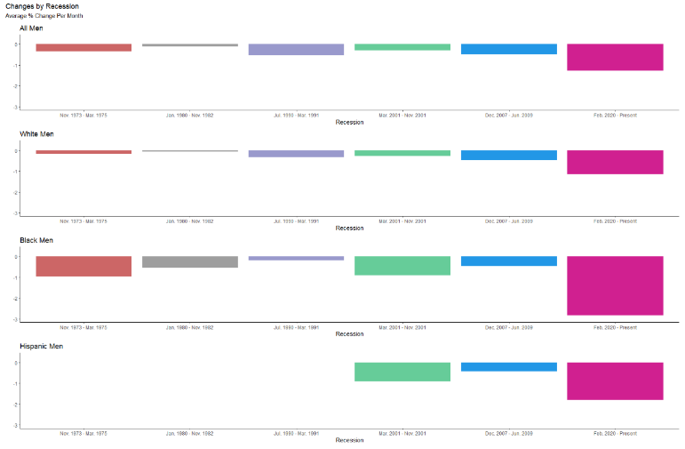**Figure 4:** Average Percent Change per Month by Expansion and Recession (1970 – 2020)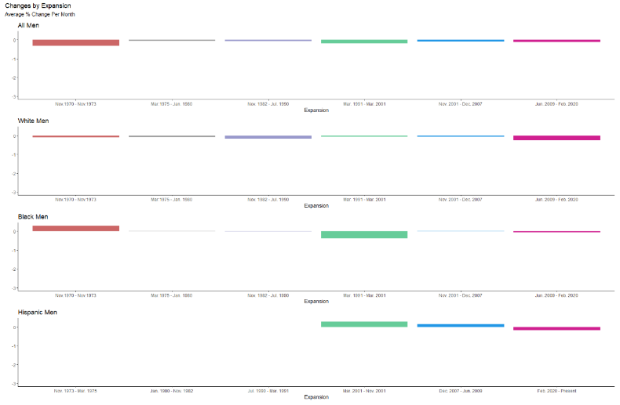

Source: author’s calculations of CPS data.

As the expansion graphs of Figure 4 show, there is little to note during expansions other than the fact that the average percent change per month is very small, though consistently negative—with the understanding that these graphs are not weighted for the length of the expansion/recession—for most demographics. The recession graphs of Figure 4 paint a much different picture. It appears that men leave the labor force at a higher rate during economic downturns, particularly during the more recent ones. This is consistent with the findings of Cortez et. al., Tüzemen, and others claiming the decline of middle skill jobs drives men out of the labor force.

The following charts in Figure 5 contain indices of the labor force participation rate of men during each expansion and recession dating back to 1973. White men’s labor force participation rate is far less volatile than that of black or Hispanic men. Bear in mind that, as with Figure 4, the y-axis scales are uniform, but x-axis scales are not the same across graphs. Further, it is important to state that the labor force participation rate for all men is seasonally adjusted, while none of the other demographics are seasonally adjusted. This is important because it would be misleading to compare the volatility of all men to another demographic. It is included to provide the general trend for where the labor force participation rate is headed during each period.

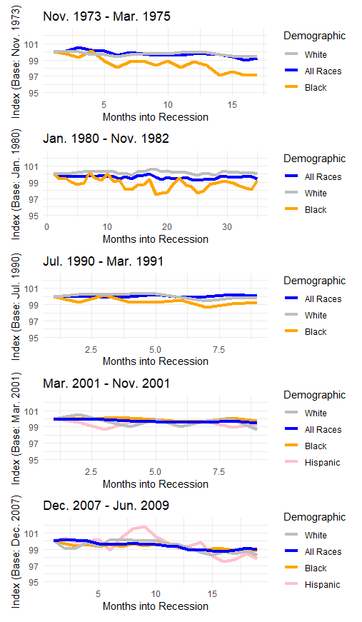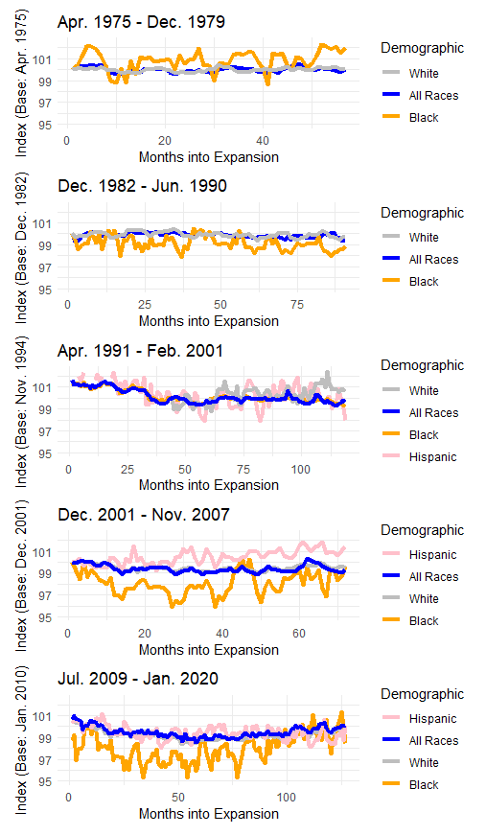**Figure 5:** LFPR Indices by Expansion and Recession (1973 – 2020)

Source: author’s calculations of CPS data.

To assist with interpretation of these results, Figure 5 should be thought of in tandem with Figure 4. The recession graphs of Figure 5 are difficult to understand, as it appears as if there is only a miniscule change during each recession. The time taken to produce the extent to which men have left the labor force during a recession is only a fraction of the time needed for the same change to occur during an expansion. Another trend worth noting is that the labor force participation rates for black and Hispanic men are quite volatile when compared to those of white men. This could be due to a variety of causes and would make an excellent follow-up study.

**ENDNOTES**

1. Datasets and code [available on GitHub](https://github.com/Ckrenzer/Declining-Prime-age-Male-Labor-Force-Participation.git).
2. See “The Rise of Services, Deindustrialization, and the Length of Economic Recovery”, by Olney and Pacitti (2017), for example.

**REFERENCES**

Berube, A. 2016. Where Are the Nonworking Prime-Age Men? *The Brookings Institution.* Retrieved from

https://www.brookings.edu/blog/the-avenue/2016/06/21/where-are-the-nonworking-prime-age-men/.

Black, S., Furman, J., Rackstraw, E., Rao, N. 2016. “The long-term decline in US prime-age male labour

force participation.” *VOXEU.* Retrieved from https://voxeu.org/article/long-term-decline-us-prime-age-male-labour-force-participation-and-policies-address-it.

Bureau of Labor Statistics. 2020. Activity Rate: Aged 25-54: Males for

The United States [LRAC25MAUSM156S], retrieved from FRED, *Federal Reserve Bank of St. Louis;*

https://fred.stlouisfed.org/series/LRAC25MAUSM156S.

Coglianese, J. 2018. The Rise of In-and-Outs: Declining Labor Force Participation of Prime Age Men.

*Federal Reserve Board of Governors.* Retrieved from https://www.aeaweb.org/conference/2019/preliminary/paper/QRfzydia.

Cortes, G.M., Jaimovich, N., Nekarda, C.J., and Siu, H.E. 2014. The Micro and Macro of Disappearing

Routine Jobs: A Flows Approach. *National Bureau of Economic Research.* Retrieved from http://www.nber.org/papers/w20307.

Council of Economic Advisers. 2016. The Long-Term Decline in Prime-Age Male Labor Force

Participation. *The White House.* Retrieved from https://obamawhitehouse.archives.gov/sites/default/files/page/files/20160620_cea_primeage_male_lfp.pdf.

Krueger. A.B. 2016. Where Have All the Workers Gone? *Princeton University and National Bureau of*

*Economic Research.* Retrieved from https://www.bostonfed.org/-/media/Documents/economic/conf/great-recovery-2016/Alan-B-Krueger.pdf.

Krueger, A.B. 2017. Where Have All the Workers Gone? An Inquiry into the Decline of the US Labor

Force Participation Rate. *The Brookings Institution.* Retrieved from https://www.brookings.edu/bpea-articles/where-have-all-the-workers-gone-an-inquiry-into-the-decline-of-the-u-s-labor-force-participation-rate/.

The Latest: Powell sees job participation as major problem (2019, November 13), *Associated Press*.

Retrieved from https://apnews.com/.

Leaker, D. 2020a. LFS: Economically inactive: UK: Male: Aged 25-34: Thousands: SA [Data file].

Retrieved from https://www.ons.gov.uk/employmentandlabourmarket/peoplenotinwork/economicinactivity/timeseries/lwfe/lms.

Leaker, D. 2020b. LFS: Economically inactive: UK: Male: Aged 35-49: Thousands: SA [Data file].

Retrieved from

https://www.ons.gov.uk/employmentandlabourmarket/peoplenotinwork/economicinactivity/timeseries/lwfe/lms.

Leaker, D. 2020c. *LFS: Economic inactivity rate: UK: Male: Aged 25-34: %: SA* [Data file]. Retrieved from

https://www.ons.gov.uk/employmentandlabourmarket/peoplenotinwork/economicinactivity/timeseries/lwfe/lms.

Leaker, D. 2020d. LFS: Economic inactivity rate: UK: Male: Aged 35-49: %: SA [Data file]. Retrieved from

https://www.ons.gov.uk/employmentandlabourmarket/peoplenotinwork/economicinactivity/timeseries/lwfe/lms.

Tüzemen, D. 2018. Why Are Prime-Age Men Vanishing from the Labor Force? *Federal Reserve Bank of*

*Kansas City.* Retrieved from https://www.kansascityfed.org/~/media/files/publicat/econrev/econrevarchive/2018/1q18tuzemen.pdf.

United Stated Congress Joint Economic Committee. 2018. Inactive, Disconnected, and Ailing: A Portrait

of Prime-Age Men Out of the Labor Force. Retrieved from https://www.jec.senate.gov/public/index.cfm/republicans/2018/9/inactive-disconnected-and-ailing-a-portrait-of-prime-age-men-out-of-the-labor-force#endnote-06.

Winship, S. 2017. Declining Prime-Age Male Labor Force Participation Why Demand- and Health-Based

Explanations Are Inadequate. *Mercatus Center.* Retrieved from https://www.mercatus.org/publications/government-spending/declining-prime-age-male-labor-force-participation.